Project Design Phase
Solution Architecture
Date | 7 July 2026
Team ID
Project Name | Darshan Ease
Maximum Marks | 4 Marks
Solution Architecture:
Solution architecture bridges the gap between the temple-darshan business problem and the MERN-stack technology solution adopted for Darshan Ease. It defines the structure, layers, and behavior of the application for all project stakeholders.
Darshan Ease – Architecture Diagram:
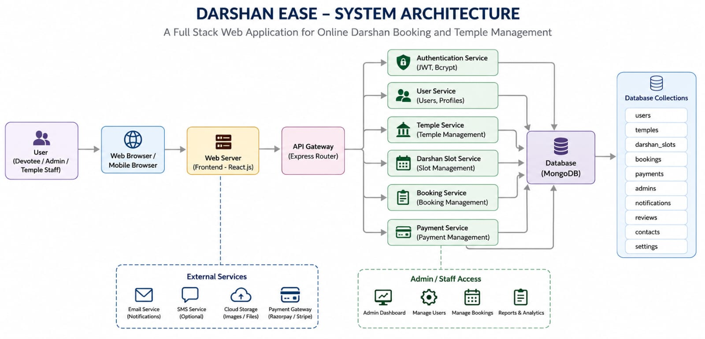
Figure 1: Darshan Ease MERN-stack architecture (Frontend – Backend – Database)
Architecture Layers – Description:
S.No. | Layer / Component | Description
1 | Presentation / Client Layer | React.js single-page application, structured with a decoupled component layout and React Router DOM for role-aware routing (Devotee, Temple Trust, Admin). Axios is used as the HTTP client to communicate with backend REST APIs, with Bootstrap/React-Bootstrap and Tailwind CSS for a responsive, mobile-friendly UI.
2 | Application / API Layer | Node.js with Express.js exposes a modular set of RESTful endpoints (auth, temples, slots, bookings, admin, stats). Middleware handles CORS, body parsing, and JWT-based authentication/authorization, routing requests to dedicated controllers and a service layer that encapsulates business logic.
3 | Data Layer | MongoDB is used as the primary NoSQL data store, accessed through Mongoose ODM. Explicitly typed schemas (User, Temple, Slot, Booking) support atomic reservation increments, validation, and relational references between collections, preventing double-booking during concurrent requests.
4 | Authentication & Security | User credentials are hashed with bcrypt/bcryptjs before storage. Stateless session handling is implemented via signed JSON Web Tokens (JWT) passed in the Authorization header, with role-based access control (RBAC) restricting Devotee, Temple Trustee, and Admin capabilities.
5 | Integration & Future Layer | Planned integrations include payment gateways (Stripe/Razorpay) for premium bookings, GPS-based real-time queue tracking, AI-based crowd forecasting, and cloud storage for identity-document verification, extending the architecture without disrupting the core MERN stack.

